**Nexus configuration in maven:**

* We need to give the repository id and the url in pom.xml, so that the pom.xml can pull the libraries from there as below.

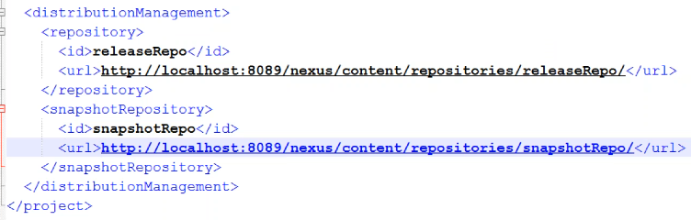

* **Mvn deploy**
* It performs all the phases of execution
* Without user credentials in pom.xml, we can’t push the code to nexus
* For that, we need to create a settings.xml file with the credentials in .m2 directory as below

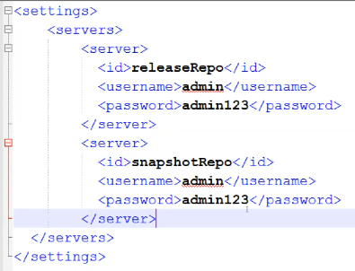

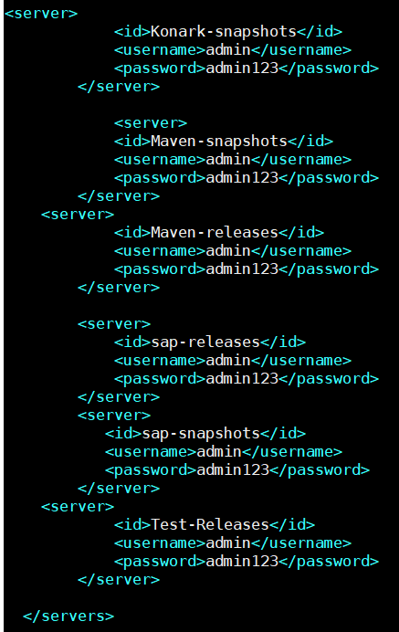

* Once this is done, we can be able to perform
* Here it publishes it on release repo
* If we mention “-SNAPSHOT” in pom.xml version, then it will publish on snapshotrepo
* If it is a snapshot version, then every time we deploy it, it will keep creating the jar files in remote repo with unique names
* If it a release version, then we can’t run it with the same name again. The version name should be unique
* We can also add profiles as below in pom.xml and pass it through the mvn command to pick the required repo.

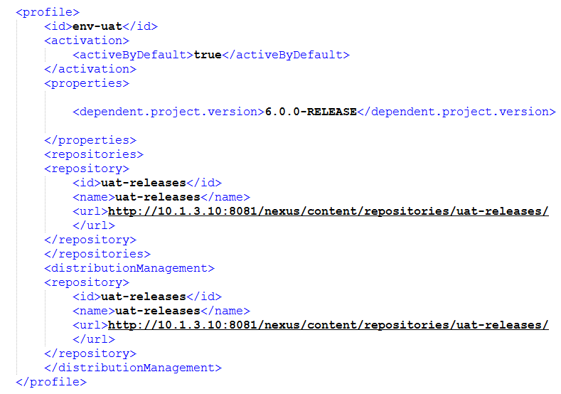

* Below is the difference between “repositories” and “distributionManagement” tags in maven pom.xml

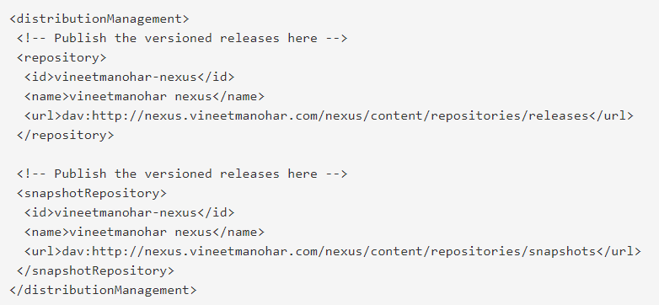

* This is to distribute the artifacts to remote repo and maintain it

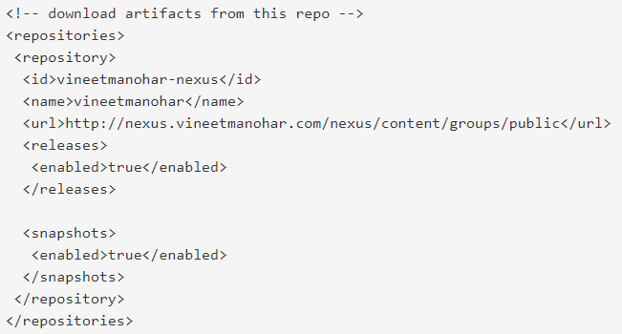

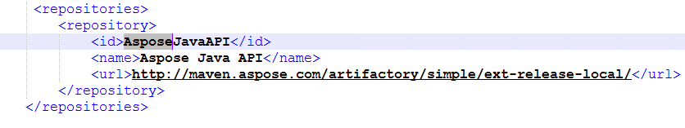

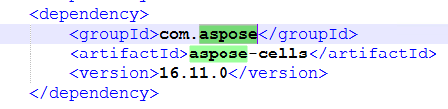

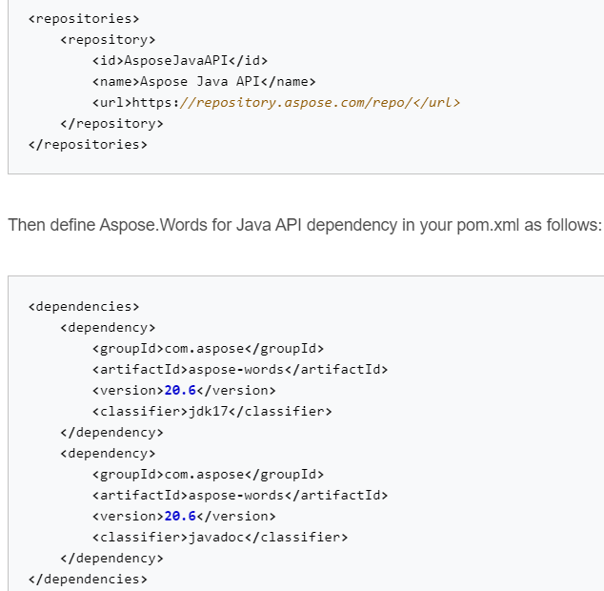

* Repositories is used for downloading the artifacts from any repository for the project.
* We can also use aspose repo as above.

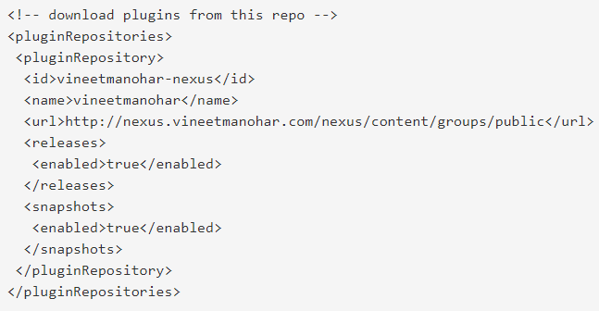

* We can also use plugin repo as above.